Bluebells Science weekly Planning - Learning Activities Autumn Term 2022
Seasonal change including weather

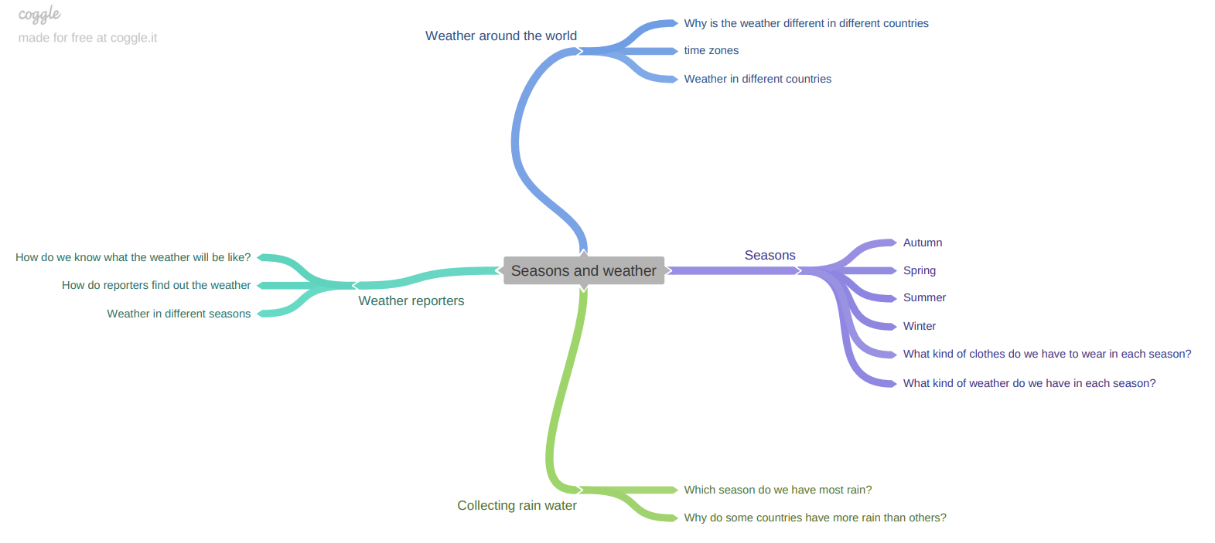

Session | Skills | Key questions | Learning activities | Writing opportunity and  evidence in books | Resources
1 | Pre-learning assessment | What do I already know about the seasons and the weather?  What do I want to find out about the seasons and the weather? | To create a mind map of what they already know about the seasons and the weather. | Mind maps of what they already know and what they want to find out. | Mind map templates.
2 | Observe and describe the weather associated with the seasons. | Which different types of weather do we have?  Is it the same in different countries around the world? | Read story – what types of weather did they experience?  Write the different types of weather down and draw pictures of that type of weather.  Start a weather chart which we can change every day throughout the year. | Writing types of different weather. | Large paper  Weather chart
3 | Name the four seasons and describe the changes that take place. | Which season are we in now? What is the weather like? What is happening around us? | Read Tree seasons come, seasons go by Patricia Hegarty.  Sorting activity – photos of Spring, Summer, Autumn and Winter.  Turn our tree into an Autumn tree. | What is your favourite season and why? | Photos  Leaves for tree  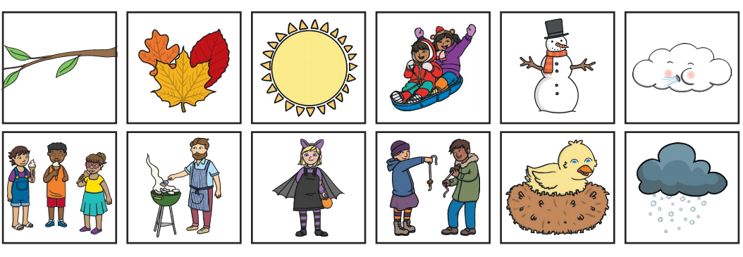
3 | Observe and describe the weather associated with the seasons.  Respond to prompts by making some suggestions about how to make an observation.  Use senses and simple equipment to make observations.  Talk about what happens and record using words and pictures.  Begin to record data in simple templates. | How can we compare the weather? How do people know how much rain they have? | Measure rainfall. Make own rain gages – would it give us the same result if they were in different areas around our school? How can we make it fair? What if we use different sized bottles to collect the rain water? | Write about what we are going to do.  Record how much rain we have collected each day. | Bottles, rulers, scissors  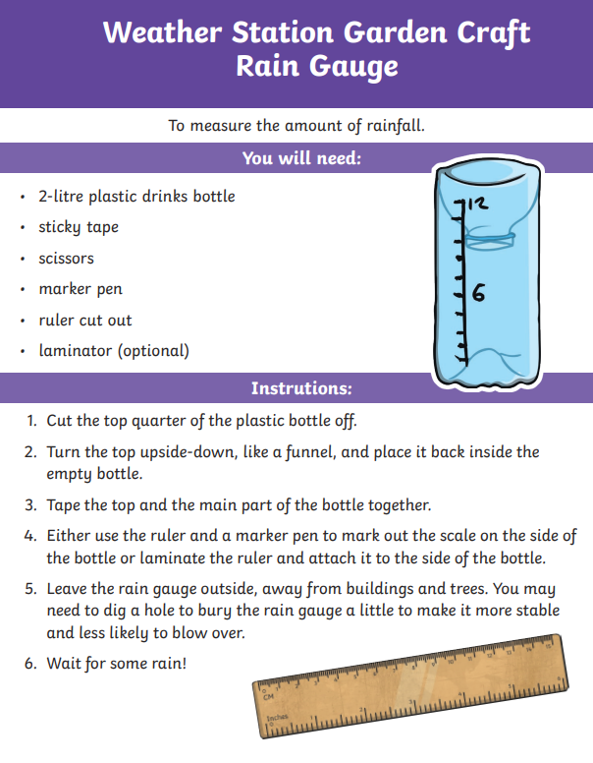
4 | Talk in simple terms about what might happen based own experiences.  Link with Geography – capital cities and the UK. | Watch a weather report. What kind of things do weather reporter say? | Make notes about what they want to include in their weather reports.  Record children being weather presenters. | Notes about the weather. | Weather map, different weather labels
5 | Post-learning assessment | What do I now know about the seasons and the weather? | Complete a mind map of what they now know about the seasons and the weather? | Mind maps of what they now know about the seasons and the weather? | Mind map templates.

