MORDA CE PRIMARY SCHOOL: Knowledge Organiser: Roses Spring 2023 RE
L2.12 Christians, Muslims and non-religious
How and why do people try to make the world a better place?

Key Skills RE | Key enquiry questions
Make sense of belief:  • Identify some beliefs about why the world is not always a good place (e.g. Christian ideas of sin)  • Make links between religious beliefs and teachings and why people try to live and make the world a better place | Is the world a good place?  Think about some of the ways in which the world is not such a good place: you could start small and local, and end up big and global e.g. from upsetting people in the dinner queue through to messing up the environment. Talk about why people are not always as good as they could be. Discuss that people prefer to do their own thing rather than obey the Creator (sin) and so keep needing to say sorry and ask for help.  What are good and bad deeds?  Recall that Christians believe God helps them through the Holy Spirit. Muslims believe people do good and bad deeds, and also need God’s mercy. • Religions suggest that people need help and guidance to live in the right way. e.g. the Ten Commandments (Exodus 20:1–21, Deuteronomy 5:1–22. Work out what people must have been doing if they needed to be given those rules. Do people still behave like that? What difference would it make if people keep these guides for living? How would it make the world a better place?
Understand the impact:  • Make simple links between teachings about how to live and ways in which people try to make the world a better place  • Describe some examples of how people try to live (e.g. individuals and organisations)  • Identify some differences in how people put their beliefs into action | Who inspires us to make the world a better place?  Explore some ideas and individuals that help inspire people to make the world a better. The Muslim belief in charity (zakah): find out what it is, and how Muslims give charity; use some examples of charities such as www.Islamic-Relief.org.uk or www.muslimhands.org.uk and find out how and why they help to make the world a better place.  Who was Mother Teresa?  Explore the lives of inspirational Christians; Mother Teresa . Consider how her religious faith inspired and guided them in their lives, and their contribution to making the world a better place.  Which organisations try to make the world a better place?  Compare the work of Christian Aid and Islamic Relief: can they change the world? • Compare non-religious ways of ‘being good without God’: e.g. what do Humanists use to guide their ways of living? Many use the Golden Rule (which is common across many religions too), using reason, listening to conscience. Look at some inspiring Humanists who fight for justice (e.g. Annie Besant fought for women’s rights) and why they did this. Look at the work of the secular charity, Oxfam. How have they made the world a better place?
Make connections:  Raise questions and suggest answers about why the world is not always a good place, and what are the best ways of making it better • Make links between some commands for living from religious traditions, non-religious worldviews and pupils’ own ideas  • Express their own ideas about the best ways to make the world a better place, making links with religious ideas studied, giving good reasons for their views | How could we make the world a better place?  Enable pupils to reflect on the value of love, forgiveness, honesty, kindness, generosity and service in their own lives and the lives of others, in the light of their studies in RE
Key Vocabulary : Eternal, wrathful, gentle ancient and wise,
Omnipotent, Omniscient, Eternal, Holy, Loving spirit
Key definitions:
Omnipotent: All powerful
Omniscient: All seeing
Erternal: through all ages.
Holy: Pure

Thursday 5th January 2023

Is the world a good place?

- Think about some of the ways in which the world is not such a good place: you could start small and local, and end up big and global e.g. from upsetting people in the dinner queue through to messing up the environment.

- Talk about why people are not always as good as they could be. Discuss that people prefer to do their own thing rather than obey the Creator (sin) and so keep needing to say sorry and ask for help.

What are good and bad deeds?

- Christians believe God helps them through the Holy Spirit.
- Muslims believe people do good and bad deeds, and also need God’s mercy.
- Religions suggest that people need help and guidance to live in the right way. e.g. the Ten Commandments
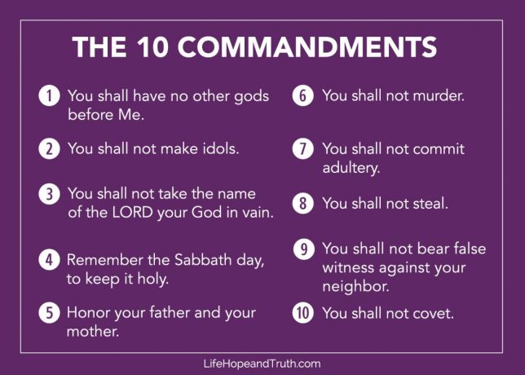

What are people doing if they needed to be given those rules?
Do people still behave like that?
What difference would it make if people keep these guides for living?
How would it make the world a better place?

Tuesday January 2023

Who inspires us to make the world a better place?

How could we make the world a better place?

The Muslim belief in charity (zakah)

https://www.youtube.com/watch?v=-GmfBeJLgoc

